21.70: Examining the forces:
So 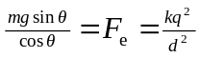But 